I’ve used a react website to implement the exercise.

Get requests to the API provided in the swagger documentation is running into CORS issues.

Please find below the screen-shot of the same.

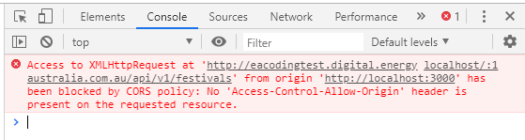

I have used the swagger response to simulate a local server to return the result set(festivals.json).

You can find the code for the above in the server project.

**Assumptions.**

1. For bands with empty/undefined record labels

I have displayed it as “Unknown label” with emphasized styling.



or



1. When the bands are not associated with a festival name I’ve displayed “No festivals Attended” with emphasized styling.

